|  |  |  |
| --- | --- | --- |
|  |  | Coaching for success  Gary.P.Calveley |

12.05.23

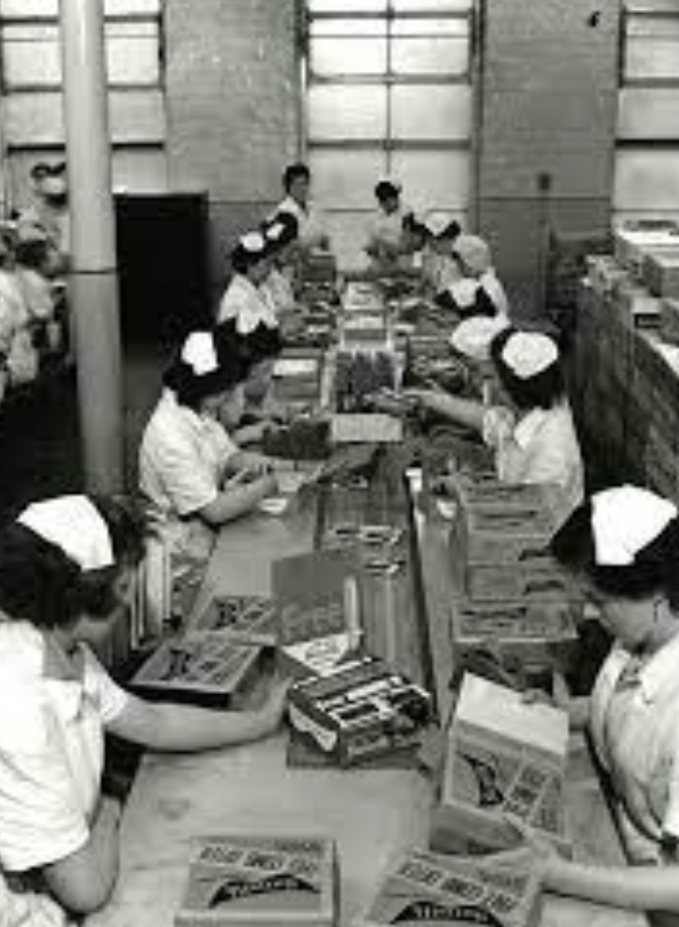

I recently posted a paper entitled,’ Why Job Titles Matter in a Manufacturing HPO Environment’. The paper describes the start of my journey in building a High Performing Organisation (HPO), which initially started with me challenging outdated, autocratic leadership styles and, in time, moved through to my first attempts at building self-managing teams.

The first real opportunity to take HPO to new levels came when I got my first Works Director’s role at Elida Faberge in Seacroft, Leeds. The first factory started life in the late nineteenth century as Joseph Watson’s Soap Factory in Leeds city centre. In time, the business was acquired by Unilever and emerged as a Personal Care factory. In the 1970s, the factory relocated to an industrial estate in Seacroft on the outskirts of Leeds. When I arrived, aerosols were dominant alongside other deodorant technologies such as sticks and roll-ones. The workforce of 500 was predominantly female with a high level of manual work, although the aerosol factory did have a higher level of automation. The factory worked a 3-shift system Monday to Friday, with overtime used at weekends to catch up on production.

The craft were all men; many were ex-miners from the Yorkshire pits who had entered the industry after the pit closures of the 1980s. They brought their bitterness and understandably had a high suspicion and dislike of management. From a leadership perspective, I was fortunate in that there were a couple of young, bright Operations Managers, Marcus Dunsmore and Chris Pote, who were challenging but open to the challenges and changes I was about to spring on them. Incidentally, post their experiences at Seacroft, both have turned out to be exceptional leaders and have gone on to have stellar careers.

Where I was most fortunate was with the HR team. Unlike the hire and fire brigade that one most often came across in HR, Alison Hackwell (who I am pleased to say is a long-standing friend and a partner in our consultancy team) and John Clayton were the complete opposite. They had a deep understanding of people, strong empathy and understanding. Their relationship with the head of the Union, Malcolm Colbeck, was extremely positive, a relationship that was open and honest, and neither side compromised the other. As a result, industrial relations were very good, although, in time, it became apparent that there was much to improve on both sides. This relationship became a crucial element of the site’s future success.

One of the KPIs I always look at before others is attendance levels (note I don’t use absence levels which I find far too negative ). In my experience, attendance is an excellent indication of morale, leadership and motivation. In my experience, the best in class is >97%. In Seacroft, it was 89%. The following KPI I like to look at is safety, particularly Total Recordable Incident Rate (TRIR) per 100,000 hours worked. The best in class is <0.3; in Seacroft, it was 3.0. I didn’t need to look at the other standard KPIs ( OEE, productivity, cost per 1000 units, etc.) to know that there was a big job. OEE was in the low 30s; productivity and cost per 1000 units were going in the wrong direction because volume had to be outsourced to third parties due to poor performance. Service levels were reasonable but at the cost of a very high inventory.

Our approach as a team was unconventional. Instead of coming down hard on the workforce and taking a more assertive and autocratic approach, we focussed on changing the culture. I took my first 100 days to dig deeper into the root causes. I spent most of my time on the shop floor listening to people. The head of the union, Malcolm and I spent many hours together, and I realised that his heart and soul were in the right place, balanced between the concerns for his members and equally wanting to ensure security for the company. He gave me some interesting feedback. Firstly he told me that management had decided everyone to wear a uniform. However, when it arrived, the women complained that it was uncomfortable, meanwhile, some of the management had opted to wear Chinos and Polo Ralph Lauren shirts. Fortunately, Malcolm had ensured they remained hidden in the warehouse. I arranged for the Salvation Army to collect the designer wear. The story hit the local press the next day ( thanks to Malcolm ). I had a fascinating discussion with the managers challenging them on why they had opted for more expensive designer wear. The silence and embarrassed faces told me all I needed to know. We agreed that we would all wear the same uniform, but we would set up a representative team to select the design and material.

Malcolm also informed me that the managers had pulled the supervisors off shift to save money. This led to anarchy after hours, including people coming onto the night shift straight from the pub ( think about it, bad enough in a standard factory but very serious in a factory manufacturing aerosols). There were also common occurrences of people leaving the night shift early, causing me a personal dilemma. You will recall from my last post that I had worked to flatten organisations and promote the concept of self-managing teams, and now here I was, being asked by the union head to put supervisors back on shift. I had to do something; my compromise was to recruit shift leaders ( note the subtle change in job title) with a requirement to manage themselves out of a job within two years.

The lesson for those who want to build the concept of self-managing / autonomous teams is that you have to prepare well. You have to train and develop your teams and your leaders first. I have never believed that flattening an organisation is a cost-saving exercise. It is about broadening people’s horizons, giving them a degree of self-worth and allowing them to take personal responsibility and grow. It is all about trust ( a topic I will cover in a later post).

My 100 days up, I pulled the Leadership team together ( again, a subtle change in job title), and we brainstormed in a local hotel for a few days. After outlining the highs and lows of what I had seen and heard, I gave the team three challenges. Within three years, I wanted the site to have achieved the following :

1. To become the safest site in Unilever

2. To win a major JIPM TPM award

3. To get external recognition by winning the UK Best Factory of the Year

My firmly held view was that in achieving these three targets, we would become highly efficient in the Operational Imperatives of Safety, Quality, Service and Cost. In doing so, we would attract volume and, therefore, security by recognising our capabilities, commitment, reliability and responsiveness. Having outlined what I wanted us to achieve, the big question was how we would achieve it. The answer was straightforward. Inspired leaders leading well-trained, empowered teams who were trusted and encouraged to make mistakes, take sensible risks and learn from them was a recipe for success.

So what did we do? First, I hired a Change Leader with the personality, empathy, drive and energy to lead this change. I knew exactly who I wanted, a trusted friend and colleague, Gene Toner. Secondly, if we were going to develop our teams to a very high level of empowerment, they needed dedicated support. So we went outside and recruited ten Performance Coaches. We had a massive recruitment drive; we involved the union and team members. None of the people we hired had ever seen the inside of a factory. They were school teachers, sports coaches, and personal coaches with one thing in common, amazing empathy with people, patience, and a ‘never give up’ attitude. The ten coaches went on shift, and their work began. Of course, we had our problems, but we started to progress through listening, talking, and trial and error.

How did you get permission or indeed afford such a move, you might ask? Well, I didn’t ask for permission. I decided to take a risk and beg forgiveness later. Authentic leadership is often about going with your gut instinct and putting your job and sometimes your reputation on the line. As for affordability, well we were bleeding costs everywhere, a few quick wins were all that was needed to set the books right. One of the groups we had trouble with was the craft team. They were initially intransigent, didn’t want to change or pass their skills onto the teams as part of autonomous maintenance within the TPM programme. I remember one particular meeting when I decided to confront them. I explained again the journey we were on, why we were taking a specific approach and explained that if successful, it would result in greater job security for all. There were a couple of agitators ( ex-miners) who were having none of it. In the end, I simply said, ‘You have two choices, work alongside us, influence us and be part of the journey or come to me with a resignation letter after this meeting, and I will gladly accept it as I don’t want unhappy people on the journey’. This seemed to take the heat out of the meeting, no one resigned, and I’m pleased to say many became coaches themselves and went on to bigger and better careers.

I won’t bore you with any more details except to say that despite the highs and lows of the journey, we did indeed hit all three targets within three years, and I proudly took a large contingent down to an award ceremony at Claridge’s in London where we were presented with the trophy for UK Best Factory Award. The organisers stated it was the best entry they had ever received.

In addition to the Unilever Safety Award (TRIR 0.2) and the JIPM award, other achievements included :

1. Attendance levels 98%

2. Aerosol volume increased by 30 % to 500,000,000 units and became the world’s largest aerosol factory, all outsourced volume brought back inside

3. We sponsored university places for several team members

4. Training & development became a way of life

5. OEE >70%

6. QDR < 5ppm

7. Productivity +5% yoy

8. TDC -15%

9. Teams allocated maintenance budgets ( which saw a 10% reduction in spend when they realised the cost of spares)

10. Annual team reviews and bonuses were introduced

What was the recipe for success? Well firstly, I built a first-class team of leaders around me who, although challenging, shared the same philosophy of using culture change to drive performance. Secondly, we put the development of our teams at the heart of the transformation. We trained and developed people to a very high level. Many women in particular, had left school at fifteen and had never had any further education. These ladies were mothers and grandmothers with unique skills. We harnessed and developed those skills, giving them purpose, respect, and a future. Finally, the role of the union leader Malcolm Colbeck was a key enabler. We involved him from the beginning and allowed him a voice and influence. When the going got rough, and teams sometimes doubted our motives, Malcolm could reassure us without ever compromising his position. If there was ever a born leader, it was him.

Before I forget, we took the shift leaders off shift and achieved a very high level of autonomy.

I hope you have enjoyed this post. The three years I spent in Seacroft were and will always be the highlight of my career. I believe that inspired leaders with high levels of empathy and emotional intelligence can lead and empower teams to very high levels of performance. I know because I have been there.

If you would like to know more, please visit our website www.sc-excellence.com. We would be very happy to support you on your journey.